**NFCSD Art Educator**

**Grade 6 – *Earth Art – Elf/Gnome/Fairy Dwelling***

**To Know:**

**Remember: Earth art** - an [art](http://en.wikipedia.org/wiki/Art) form that is created in [nature](http://en.wikipedia.org/wiki/Nature), using [natural materials](http://en.wikipedia.org/wiki/Natural_materials).

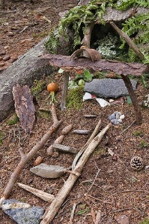Everyone knows Fairies, Elves, and Gnomes love the “local habitat,” so you need to make it very special from things you find right around the area outside where it’s built.

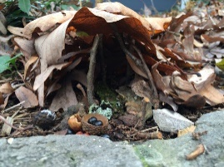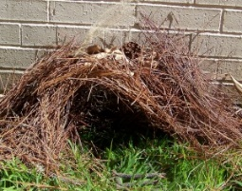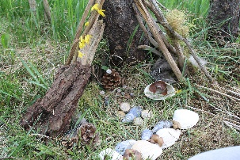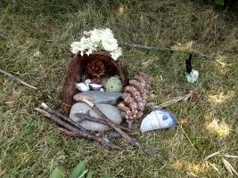

**Optional further study: search Woodland Fairy Homes or read the book, “Fairy Houses,” written and Illustrated by Tracy Kane**

**Supplies:** Stuff you can find from nature

**Optional Supplies:** Something to hold the items you collect; to move them to where you are creating. A cell phone to take a picture of your creation or whatever you’d like to make sketch of it; like a pencil & paper, if you want a keepsake of your work.

**To Do:**

*Take a walk in your yard, around your neighborhood, or at a park (remember to be at a safe distance, like 6 feet or more from others). Look for things that you think might be good to enhance the look of a tiny home or “dwelling” for a Fairy, Elf or Gnome.

>>> **Think about**: the colors, shapes and textures of the things you find

and how they might be used to represent things in your tiny home and yard.

What are things you’d like at your house that you think would be inviting? <<<

*Find a good spot to create your dwelling, like beside a boulder, in the crux of a tree, up against a building, or where ever your imagination tells you looks like a good spot for a little home. A place that’s a bit hidden is best so you don’t scare your fairies, or elves with too much noise. (Don’t worry about gnomes, they don’t scare that easily.)

* Keep the house small. If it were too big, they would want to live there, because it will be too obvious. A house that sticks out will also attract trolls, or other predators, which hurt them. Also, people who don't like fairies, elves or gnomes called "stompers", will smash a house that is too big and obtrusive. You could add a little pool for their feet.... But don't make it too big or their wings will get wet.

*Don't use plastic, duct tape, staple gun, hot glue gun, or anything that will make the fairy house intentionally permanent, or a possible hazard to wildlife. Songbirds, small rodents, amphibians, in addition to gnomes, may get stuck or injured on staples, glue or duct tape.

*You most certainly won’t see the littles when they move in, but you might want to find something shiny or sprinkle with a bit of fairy dust to attract them. Add a pinch of extra-strong belief and they’re almost guaranteed to come, even if you don’t see them. ;) Use your imagination and have fun!

**Mission Accomplished:**

Composed a **camouflaged dwelling/home**

**Architecture:**

**The art or practice of designing and constructing buildings**

**Camouflaged:**

**Blends in with the surroundings**

* Uses elements found in nature from the surrounding area
* Combine elements to represent useful things for the comfort

of those who will “live” there

Organized thoughtful **color & shape** choices

* Able to show your creation to someone and

tell them all about it

Craftsmanship **skills** are evident

* Artwork displays details
* Clear, easy-to-read representations